Name: Abida Abbas

Course: Information Security

Sir Rana Abu Bakr

Roll: Bcs-18-67

Session: 2018-2022

7th semester Morning

Assignment Web SQL-Injection

**1.**

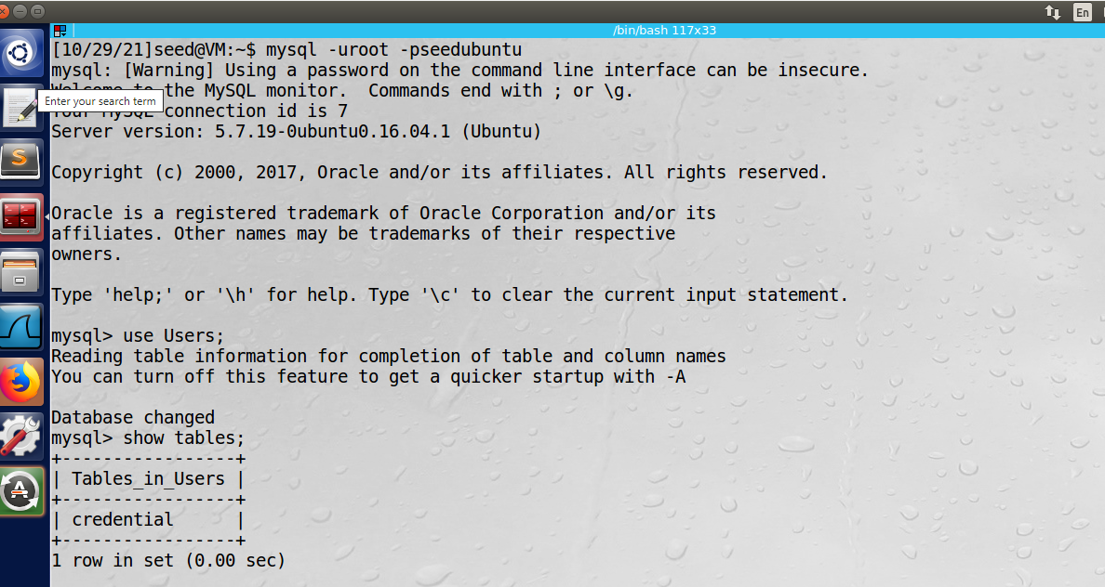

**2.**

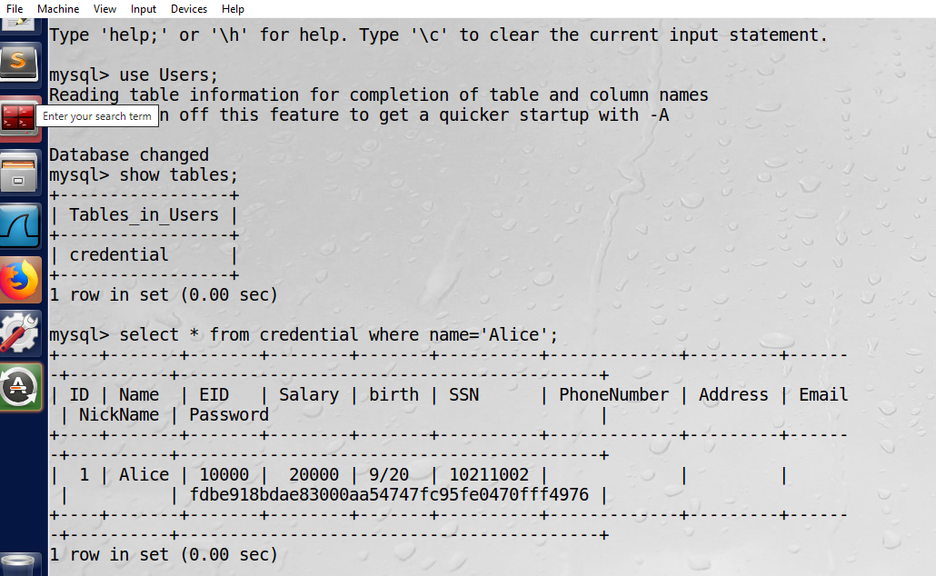

**3.**

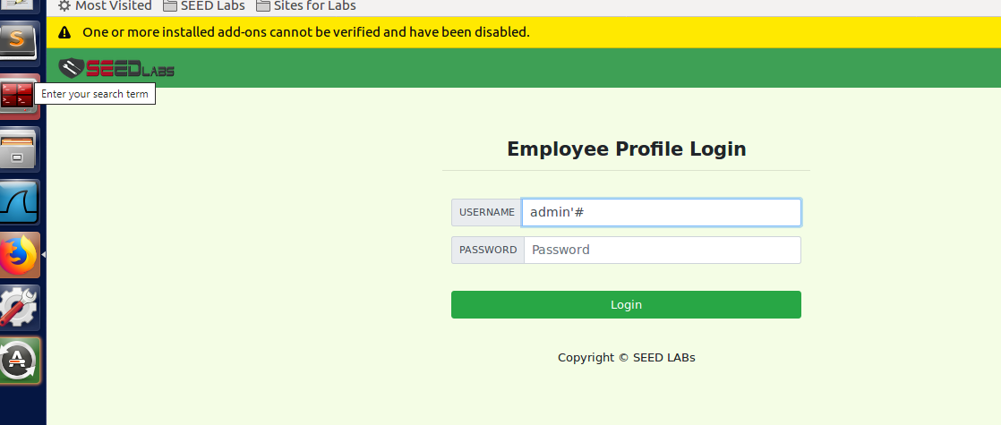

**4.**

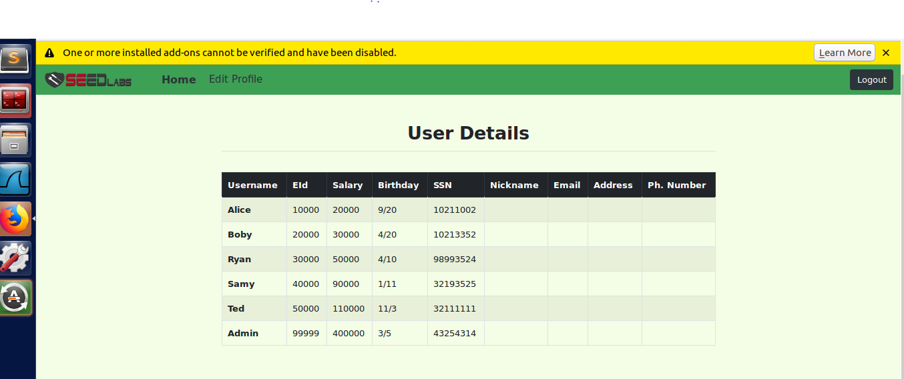

**5.**

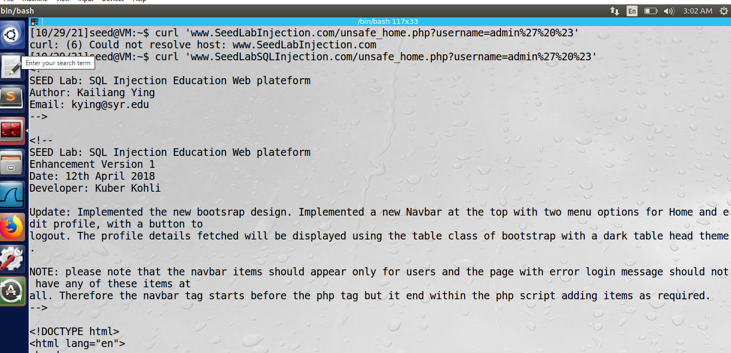

**6.**

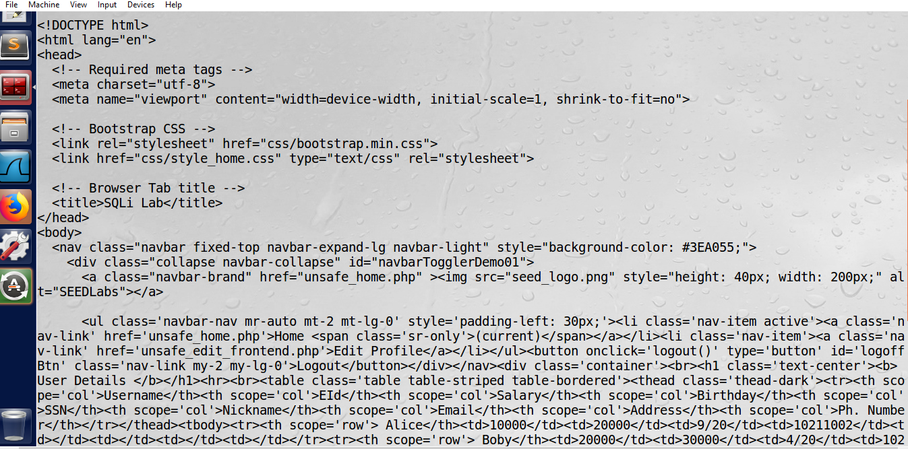

**7.**

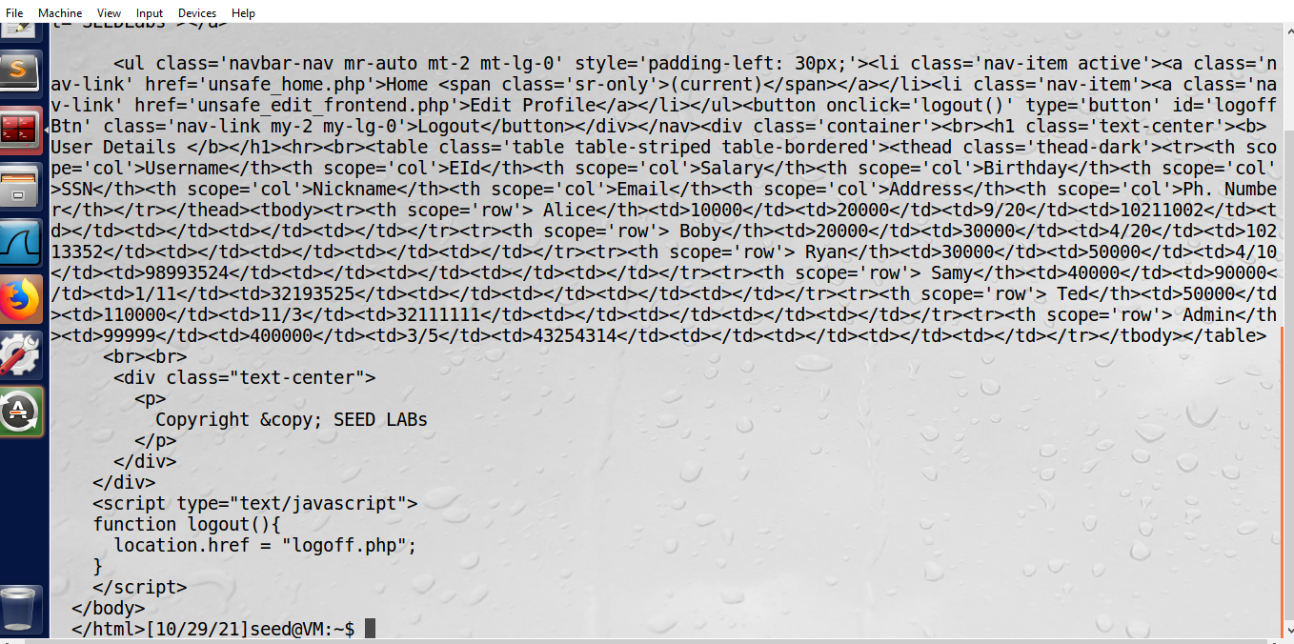

**8.**

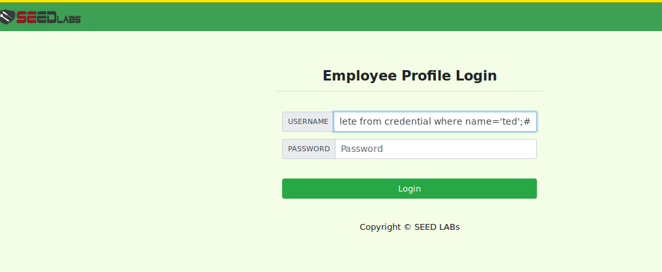

**9.**

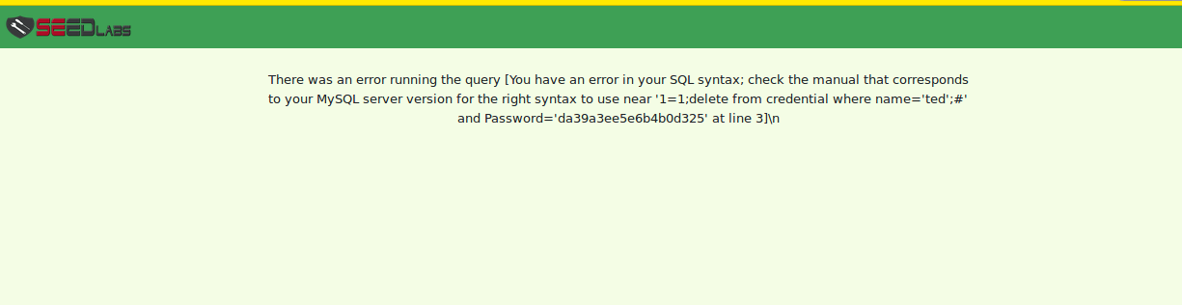

**10.**

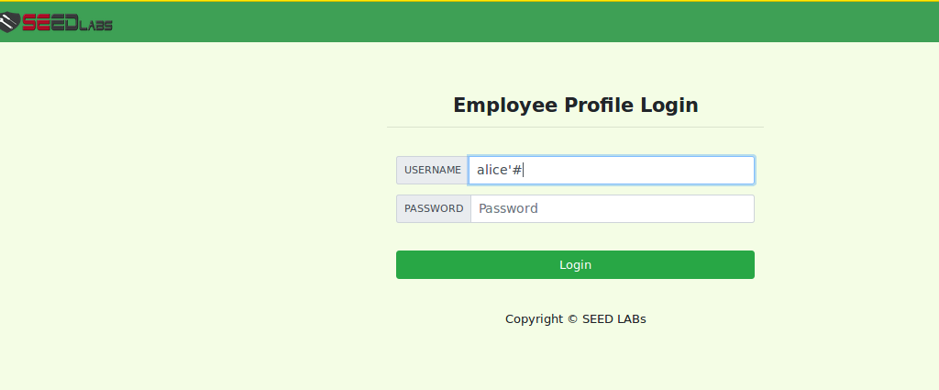

**11.**

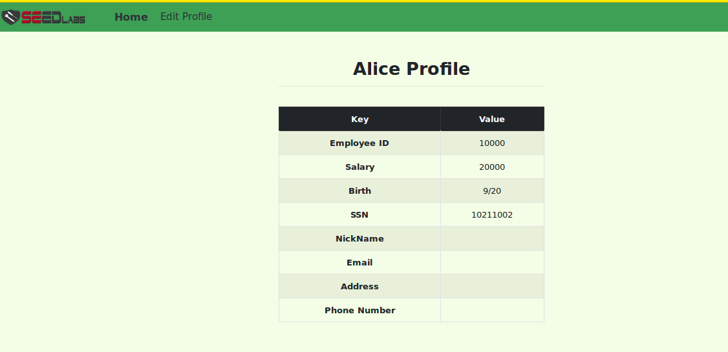

**12.**

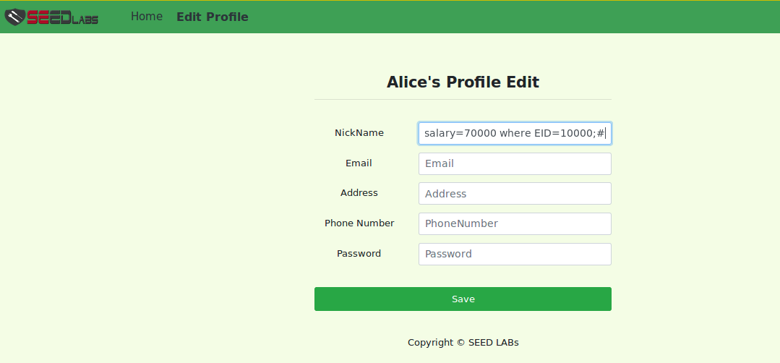

**13.**

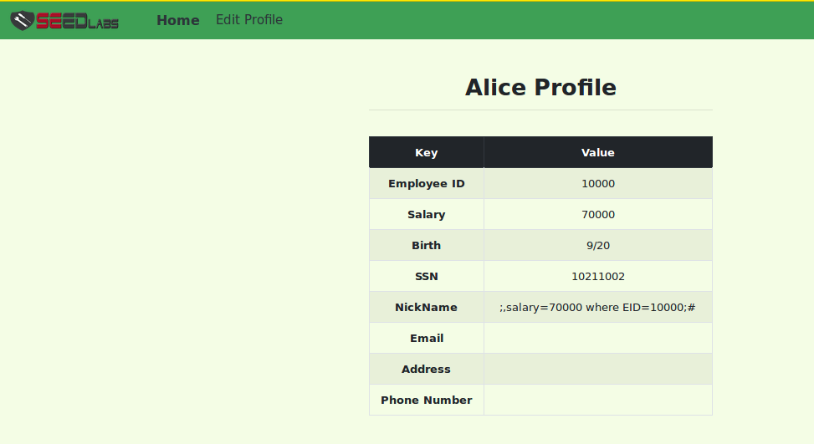

**14.**

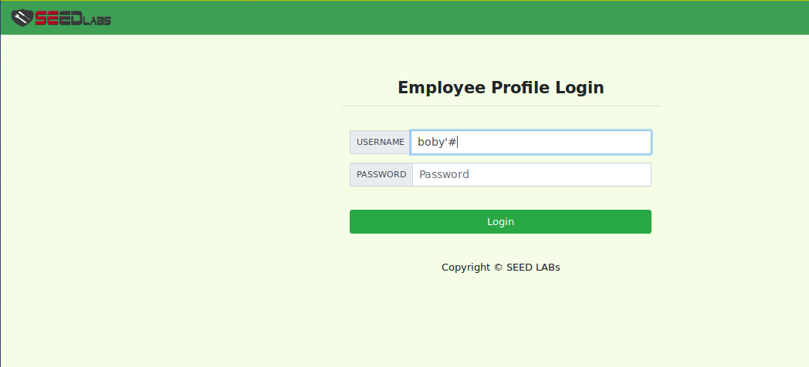

**15.**

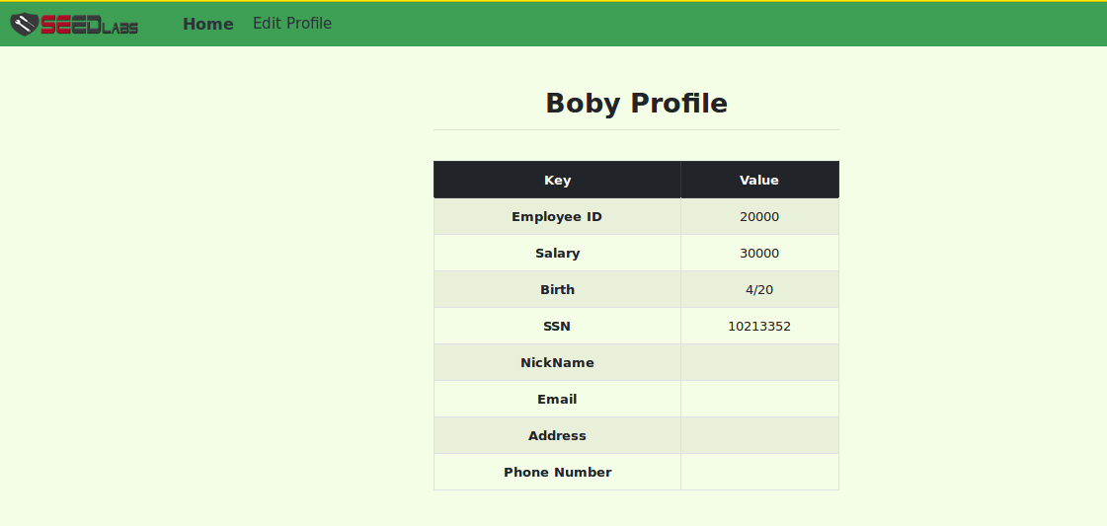

**16.**

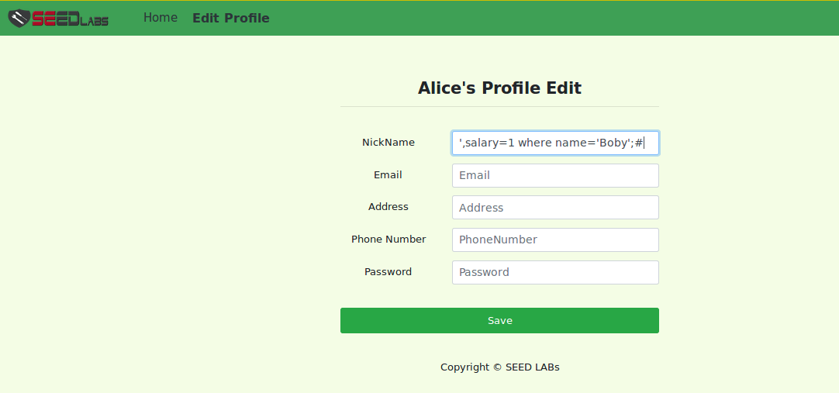

**17.**

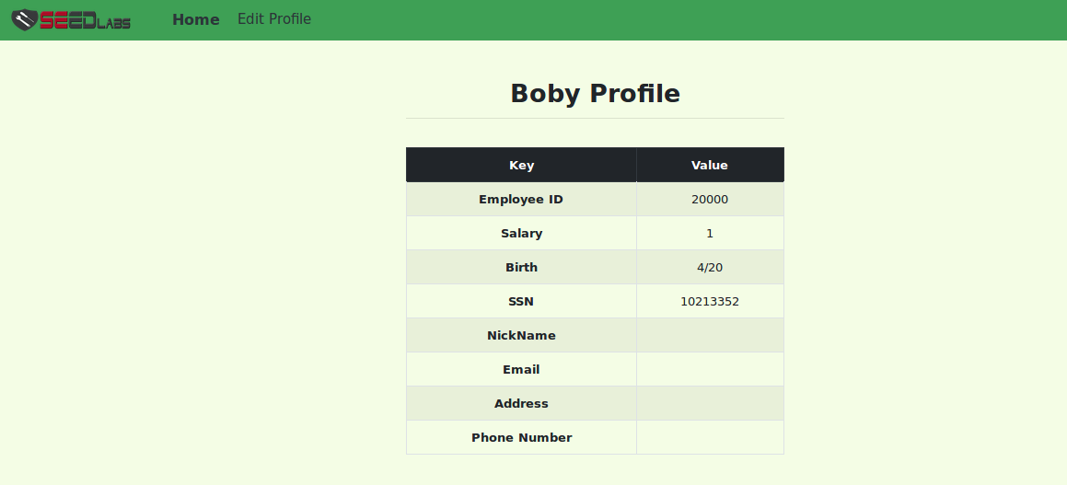

**18.**

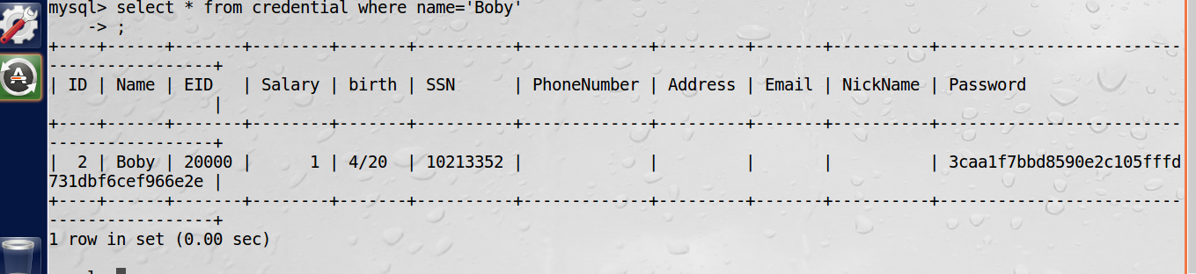

**19.**

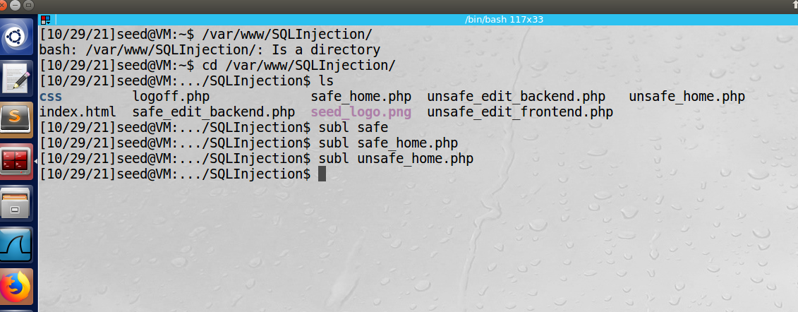

**20.**

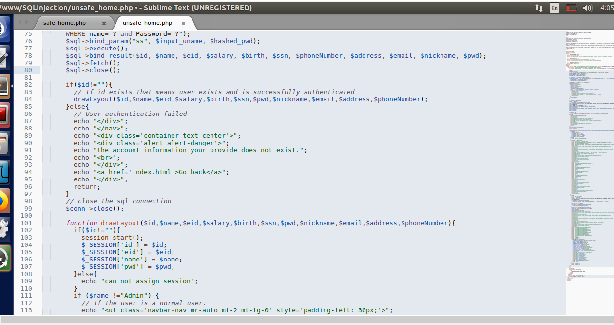

**21.**

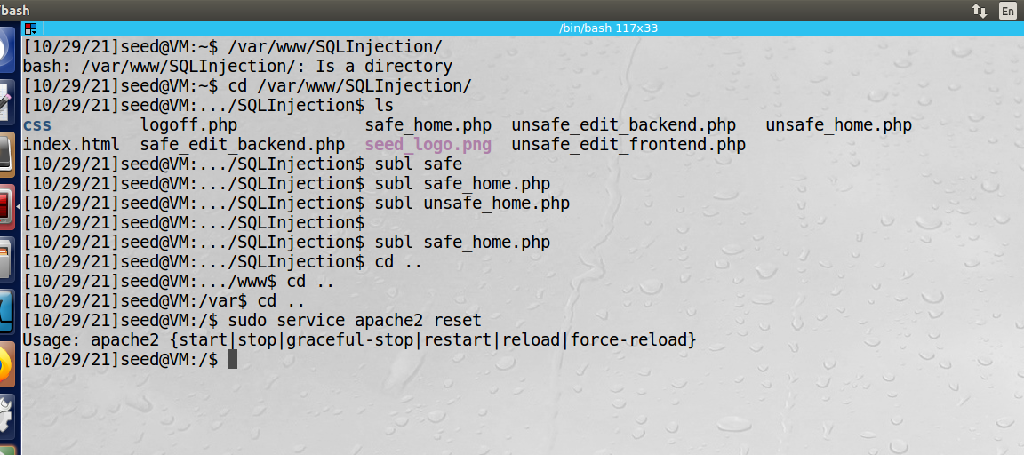

**22.**

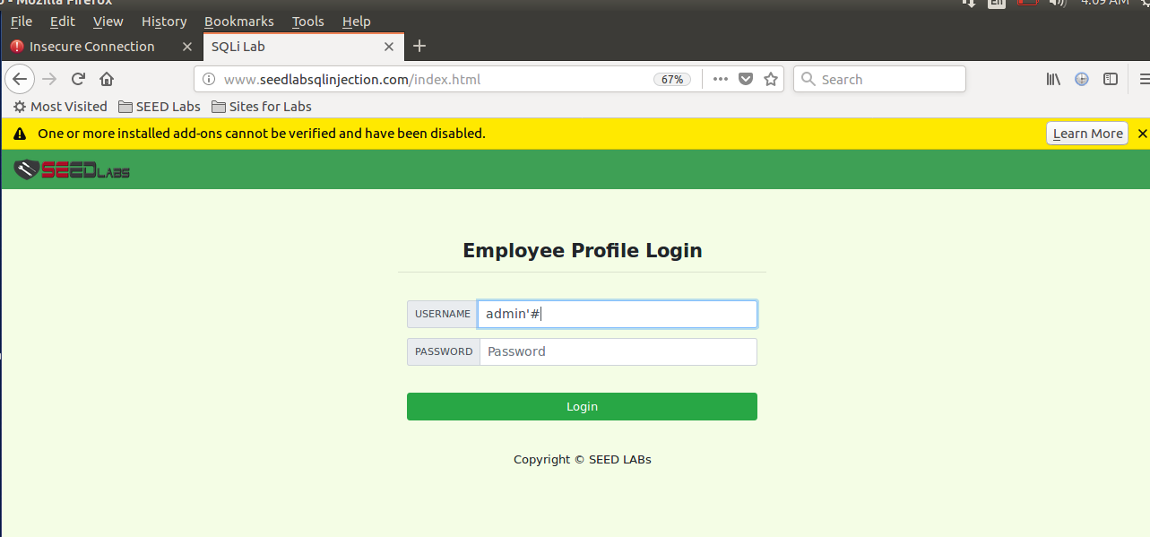

**23.**

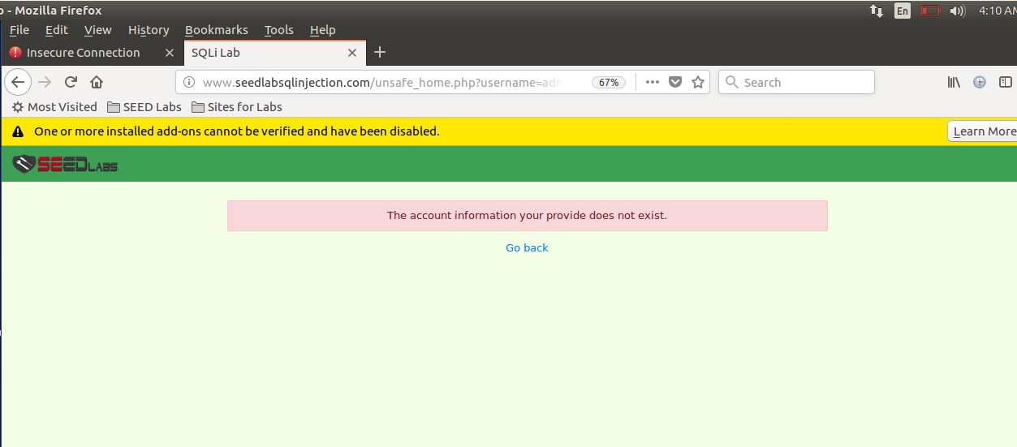

**Explanation:**

Suppose we want to hack data of a company. Firstly we will check out of which user’s data is there in that database system. To perform this task in which we will come to know about all the user’s data of the company. We will do SQL-injection coding on SEEDLAB software. It will show a dialogue box where we have to put the username and its password to access that company’s database system. And remember we don’t know that username and password either. So we will just simply write admin with special characters and click on ‘ login’ button. The User Details will be shown as you can see in the fourth picture. We could then see information of all the users that are placed on that company’s database system which we access through this procedure.

As you can see in the fourth picture.

Secondly we will the do some coding or you can say give commands in SQL-injection method

After these commands execution it will show the ‘login dialogue box’ again and this time we will enter the name of the user in the username and password of which data we want to get. And press on login button. It will show that username details suppose we entered name ‘Alice’ and it show us the profile and all the data of Alice that take place in that database system. As you can see in the eleventh picture.

After that we need to give commands of ‘save’ and ‘un save’ and also reset the data. So that next time we login it will show ‘’ your information doesn’t provide’’ means now we can’t access the information as we reset it after hacking data. It’s important to reset commands after you get information what you want so that the hacking process won’t save and shown to that user or company. So for our security and convenience we will reset all the commands that we done or perform using the software to access some company’s information.

**THE END**